Creating Microservices for account and loan

**Account Microservice**

**1.Project Creation Using Spring Initializer**

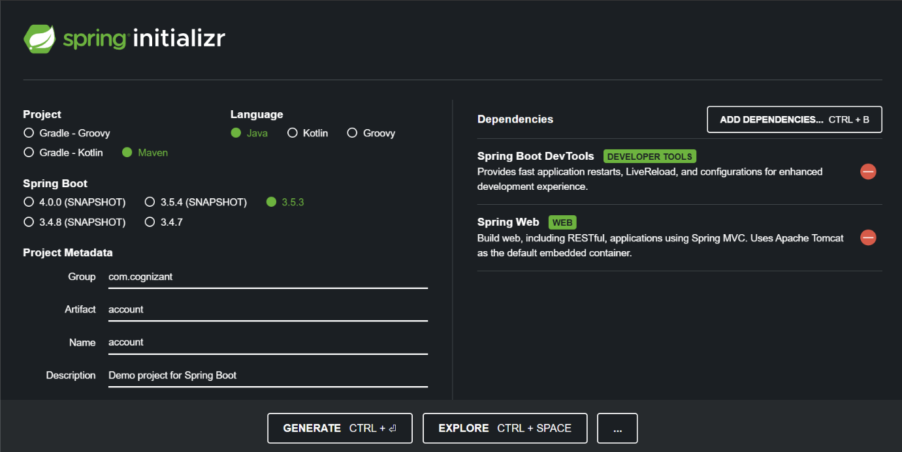

**2. Project Setup**

* Extract the ZIP.
* Move the account folder into D:\123456\microservices.
* Open command prompt inside D:\123456\microservices\account

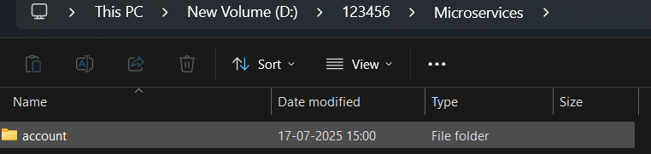

**3. Import and Code in Eclipse**

* Import the Maven project into **Eclipse IDE**.
* Inside the com.cognizant.account.controller package, create a controller class

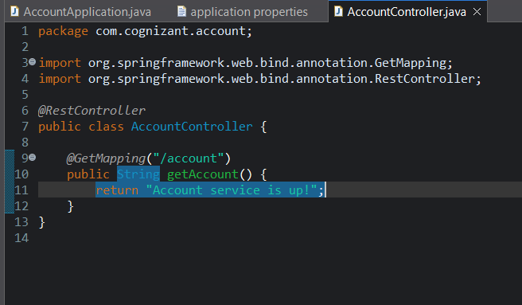

**4. Run and Test**

* Run the application.
* Open browser:  
   <http://localhost:8080/accounts/00987987973432>

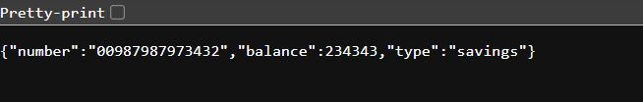

**Loan Microservice**

**1.Create Using Spring Initializer**

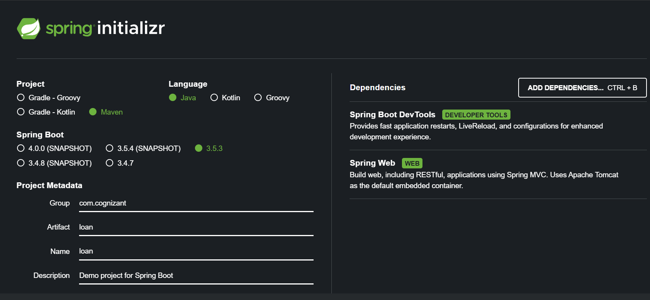

**2. Setup and Build**

**Extract loan folder and move it to D:\123456\microservice**

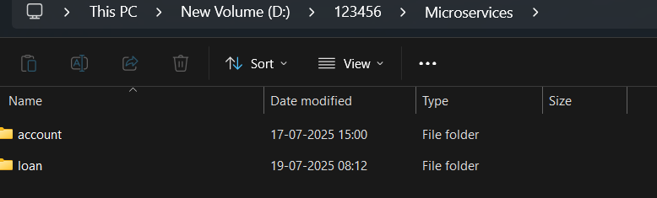

**3. Update Port**

* **Edit src/main/resources/application.properties:**

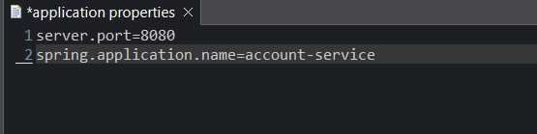

**4. Implement Controller**

* **Create a class inside com.cognizant.loan.controller:**

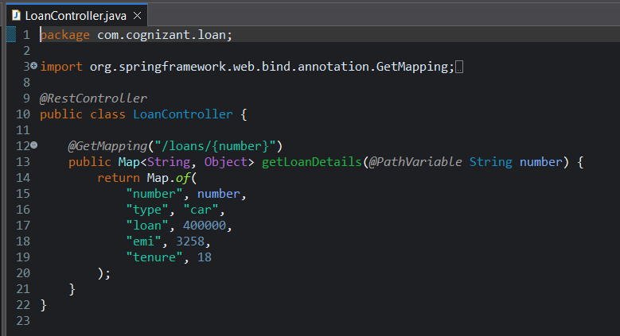

**5. Run and Verify**

* **Keep account service running on port 8080.**
* **Start loan service (it runs on 8081).**
* **Open browser:**[**http://localhost:8081/loans/12345**](http://localhost:8081/loans/12345)

